**Bahria University,**

**Karachi Campus**

**COURSE: SEN-401**

**CLOUD COMPUTING**

**TERM: SPRING 2024, CLASS: BSE- 6(B)**

**Submitted By:**

**AIMAN ZIA SATTI__________________________79301**

**Name Reg. No.**

**Submitted To:**

**Engr. Faisal/Engr. Noor us Sabah**

**Signed Remarks: ____**

**INDEX**

|  |  |  |  |  |
| --- | --- | --- | --- | --- |
| **SNO** | **DATE** | **LAB NO** | **LAB OBJECTIVE** | **SIGN** |
| 01 | 15/Feb/2024 | 01 | Intro To Cloud Computing |  |
| 02 | 22/Feb/2024 | 02 | Creating Virtual Machine Using Microsoft Azure |  |
|  |  |  |  |  |
|  |  |  |  |  |
|  |  |  |  |  |
|  |  |  |  |  |
|  |  |  |  |  |
|  |  |  |  |  |
|  |  |  |  |  |
|  |  |  |  |  |
|  |  |  |  |  |
|  |  |  |  |  |

**TASK # 1:** Create Windows Virtual Machine in Azure.

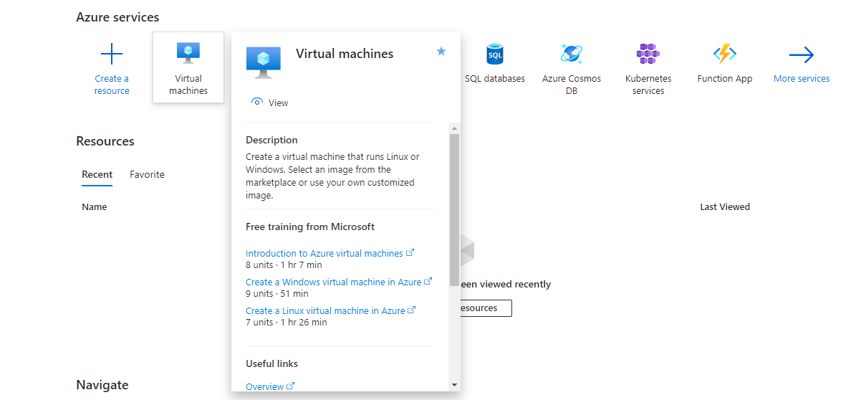

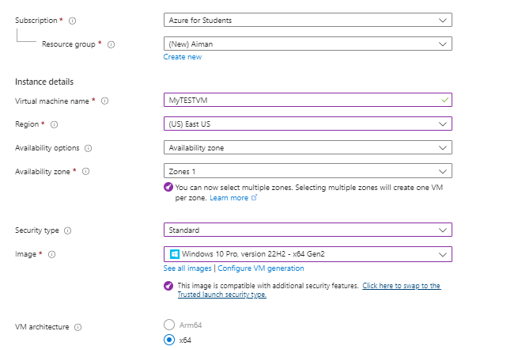

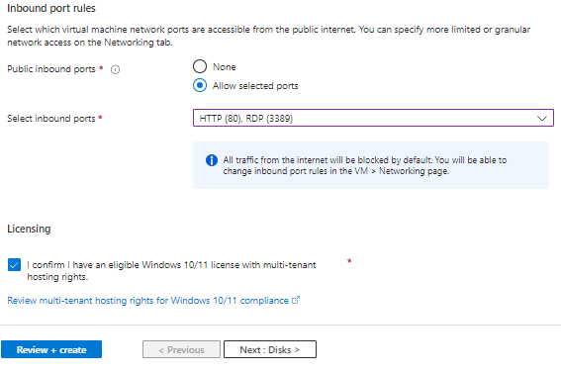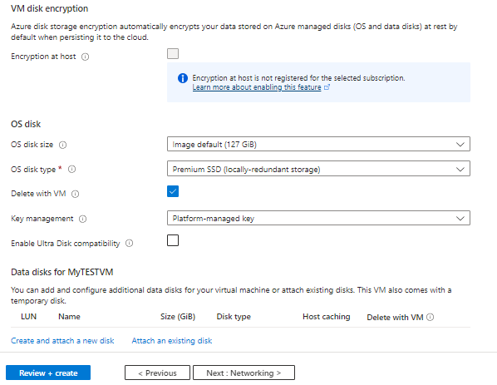

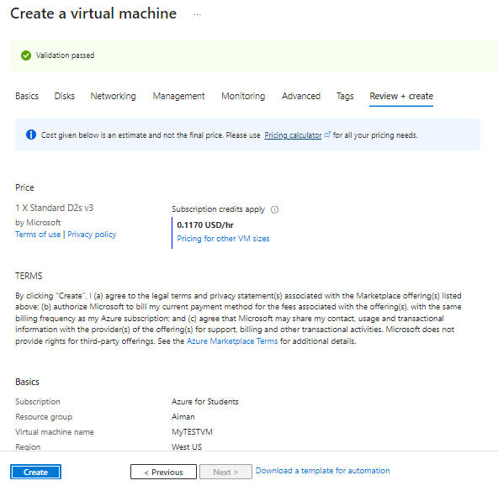

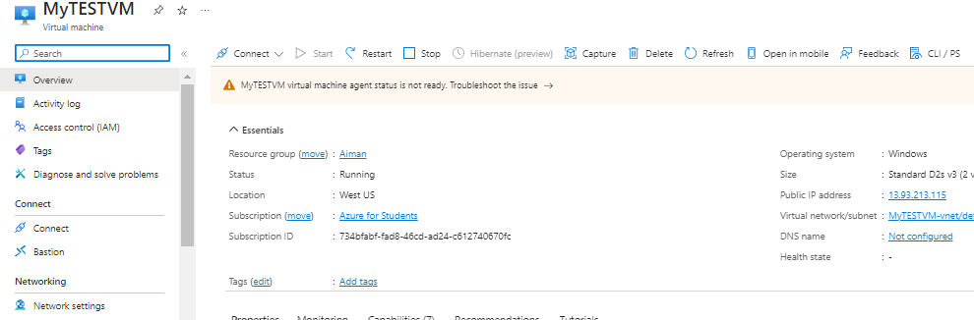

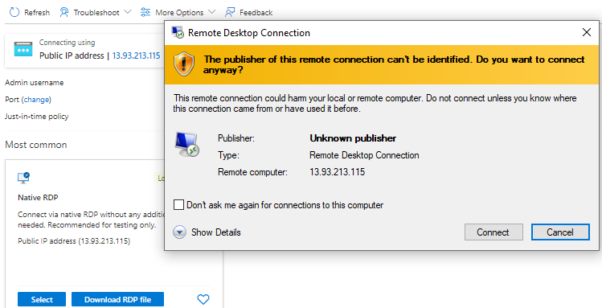

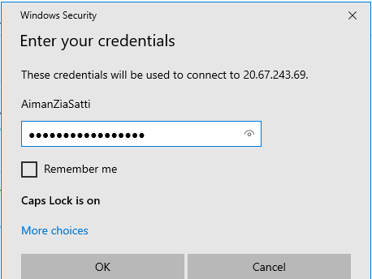

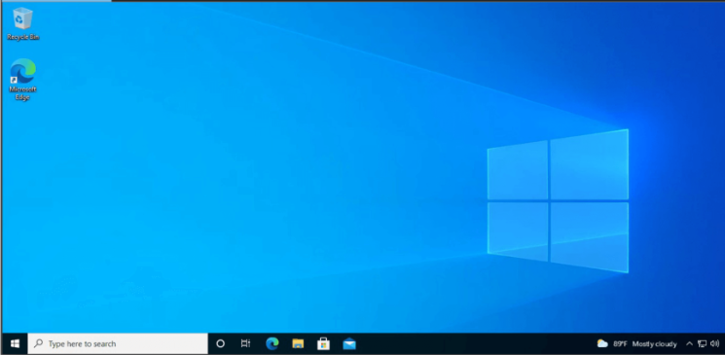

**TASK # 2:** Install different software on the created VM (including VS Code and Dev++).

**TASK # 3:** Create simple login and sign up page on VS Code using VM.

<!DOCTYPE html>

<html lang="en">

<head>

<meta charset="UTF-8">

<meta name="viewport" content="width=device-width, initial-scale=1.0">

<title>Login & Sign Up</title>

<link rel="stylesheet" href="styles.css">

</head>

<body>

<div class="container">

<form id="loginForm" class="form">

<h2>Login</h2>

<input type="text" id="loginUsername" placeholder="Username" required>

<input type="password" id="loginPassword" placeholder="Password" required>

<button type="submit">Login</button>

</form>

<form id="signupForm" class="form">

<h2>Sign Up</h2>

<input type="text" id="signupUsername" placeholder="Username" required>

<input type="password" id="signupPassword" placeholder="Password" required>

<button type="submit">Sign Up</button>

</form>

</div>

<script src="script.js"></script>

</body>

</html>

body {

font-family: Arial, sans-serif;

background-color: #f0f0f0;

margin: 0;

padding: 0;

}

.container {

display: flex;

justify-content: center;

align-items: center;

height: 100vh;

}

.form {

background-color: #fff;

padding: 20px;

border-radius: 8px;

box-shadow: 0 0 20px rgba(0, 0, 0, 0.1);

width: 350px;

text-align: center;

}

.form h2 {

margin-bottom: 20px;

color: #333;

}

input[type="text"],

input[type="password"],

button {

width: 100%;

margin-bottom: 15px;

padding: 12px;

border: 1px solid #ccc;

border-radius: 4px;

box-sizing: border-box;

font-size: 16px;

}

button {

background-color: #007bff;

color: #fff;

border: none;

cursor: pointer;

transition: background-color 0.3s ease;

}

button:hover {

background-color: #0056b3;

}

.link {

font-size: 14px;

color: #007bff;

text-decoration: none;

transition: color 0.3s ease;

}

.link:hover {

color: #0056b3;

}

document.getElementById('loginForm').addEventListener('submit', function(event) {

event.preventDefault();

alert('Login button clicked');

});

document.getElementById('signupForm').addEventListener('submit', function(event) {

event.preventDefault();

alert('Sign Up button clicked');

});



